Proiect SCIA



Supervisor: Student:

Dr.Ing.Prof.Marius Neag Morar Horea-Razvan
Dr.Ing.Prof Onet Raul Ciprian Gr 2331

1.Project Thematic

The project aims to design and implement an analog interface that meets the specific requirements for use in analog signal processing applications. The interface consists of 4 blocks, connected in cascade, each with a specific role:

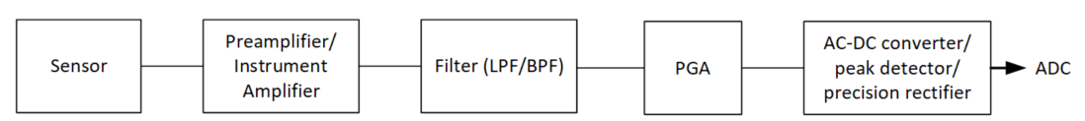

Given specifications: The first stage was configured as a passive current feedback instrumentation amplifier, with the following circuit:

And it has the following specifications:
1.Maximum amplitude (for minimum PGA gain): 1.06E-01
2. Minimum amplitude(for maximum PGA gain) : 5.33E-02
3.Unit of measurement : Voltage(differential)
4.Linear and modulus gain : 10

The second stage is a Analog Low-Pass Filter (KHN) with the following circuit:

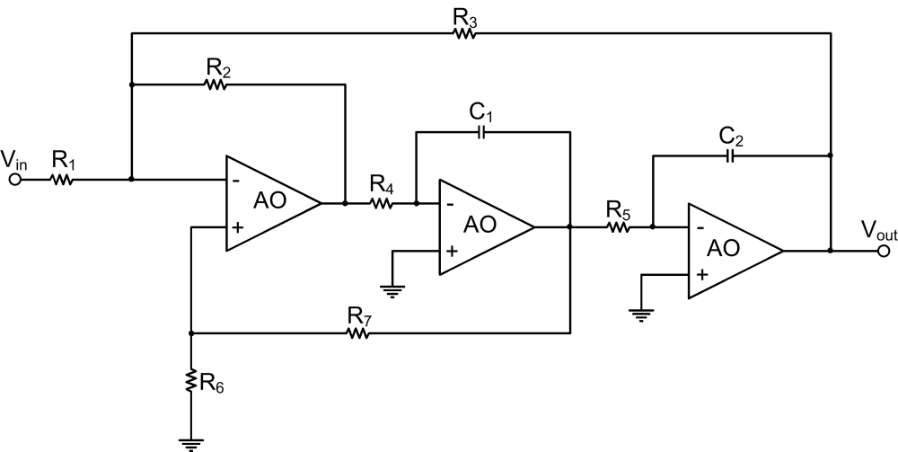

And it had the given specifications:
1.|H0| , linear gain in pass band : 1.00E+00
2.Minimum input resistance: 1.00E+03
3.Band : 6000 Hz
4.Quality factor, Q : 0.707

The third stage is a programmable gain amplifier with RG Parallel with the following circuit:

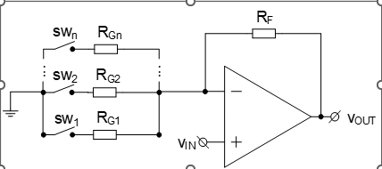

And it has the given specifications:
1.Minimum gain in dBs : 9 dB
2.Resolution(minimum step) : 2 dB
3.Total number of steps : 4
4.Maximum gain in dBs : 1.50E+01

The fourth stage is a precision full-wave rectifier with the following circuit:

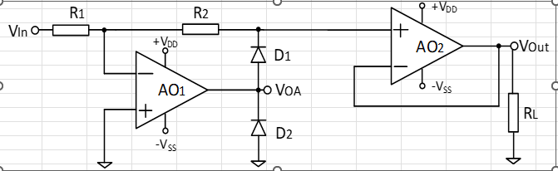

And it has the given specifications:
- Gain (modulus and linear) : 1

2.Sizing of Stages 1 / 2 / 3 / 4

2.1.Sizing of the first stage:

Based on the following formula:

$Av=\frac{Vo}{Vid}=\frac{Vo}{Va-Vb}=1+2* \frac{Rf}{Rg}$ (1)

And the already known gain 𝐴𝑣 = 10 results the following:
$10=1+2* \frac{Rf}{Rg}$ (2)
9=2*$\frac{Rf}{Rg}$ (3)

From which we get the following ratios of $\frac{Rf}{Rg}$= $\frac{9kΩ}{2kΩ}$

And knowing this we could just select a value for the Rc resistances from the above circuit , which was 5k. This ensured us the necessary gain of 10.

2.2.Sizing of the second stage:

Dimensional parameters:

1. Resistors:
$$R1=R2=R3=....=R7=R=>Ho=1;ω_{0}=\frac{1}{R\sqrt{C1C2}};Q=\frac{2}{3}\sqrt{\frac{C1}{C2}}$$

I chose R=15.9k Ω

- Capacitors:

$ω_{0}=2πf_{c}=2π6000=37.680$ (1)

$C_{1}=\frac{3Q}{2ω_{0}R}=\frac{3*0.707}{2*37.680*15.9k}=1.77nF$ (2)

$C_{2}=\frac{4C_{1}}{9Q^{2}}=\frac{2}{3Qω_{0}R}=\frac{2}{3*0.707*37.680*15.9k}=1.57nF$ (3)

2.3.Sizing of the third stage:

Resistors:

We choose Rf=10k

$\left|A_{v}\right|=\left\{9dB,11dB,13dB,15dB\right\}=\left\{2.82V,3.55V,4.47V,5.62V\right\}$ (1)

$A_{v}=\frac{R_{f}}{R_{g}}=>R_{g}=\frac{R_{f}}{A_{v}}=>$ (2)

$\left\{\begin{aligned}R_{1}=3.6kΩ \\ R_{2}=2.82kΩ \\ R_{3}=2.23kΩ \\ R_{4}=1.8kΩ\end{aligned}\right.$ (4)

SW1 | SW2 | SW3 | SW4 | $R_{f}$[Ω] | R[Ω] | $$A_{v}[dB]$$ | $A_{v}$[$\frac{V}{V}$]
VDD | 0 | 0 | 0 | 10k | 3.6k | 9 | 2.82
0 | VDD | 0 | 0 | 10k | 2.82k | 11 | 3.55
0 | 0 | VDD | 0 | 10k | 2.23k | 13 | 4.47
0 | 0 | 0 | VDD | 10k | 1.8k | 15 | 5.62

2.4.Sizing of the fourth stage:

For the fourth stage we choose R=10kΩ and we keep in mind the fact that the resistors need to be equal in order to get the gain 1.

3.Characterization of Stages 1 / 2 / 3 / 4

3.1.Characterization of Stage 1

DCOP Parameters:

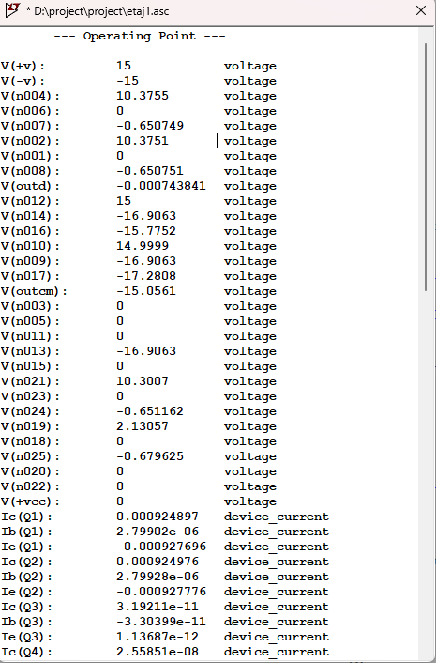
Demonstration of low frequency gain:
Simulation used: .ac dec 100 .01 100Meg

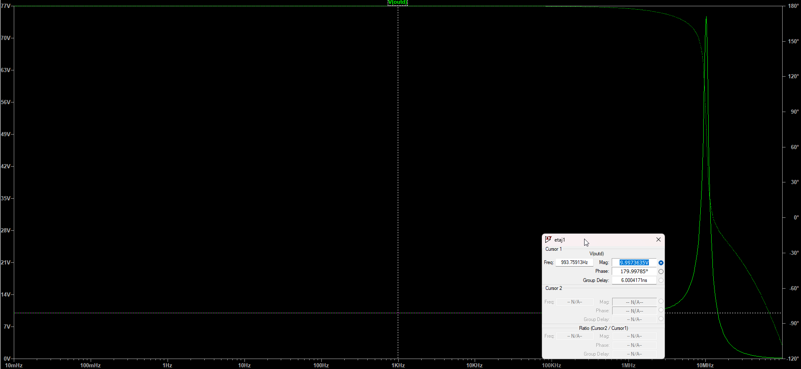

Value obtained is 9.997 which approximately is 10 , which was the given spec.
The spike is a overshoot because of the Opamp AD8065

Demonstration of band higher than that of filter
Simulation used: .ac dec 100 .01 100Meg

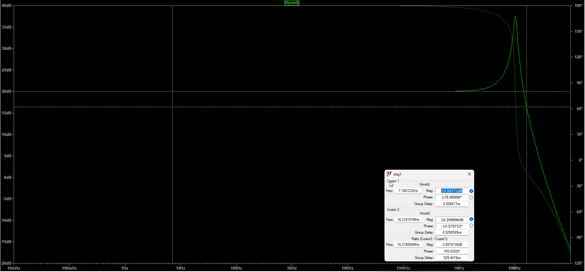

Demonstration of CMRR,PSRR along with proper values.
Simulation used: .ac dec 100 .01 100Meg

CMRR:

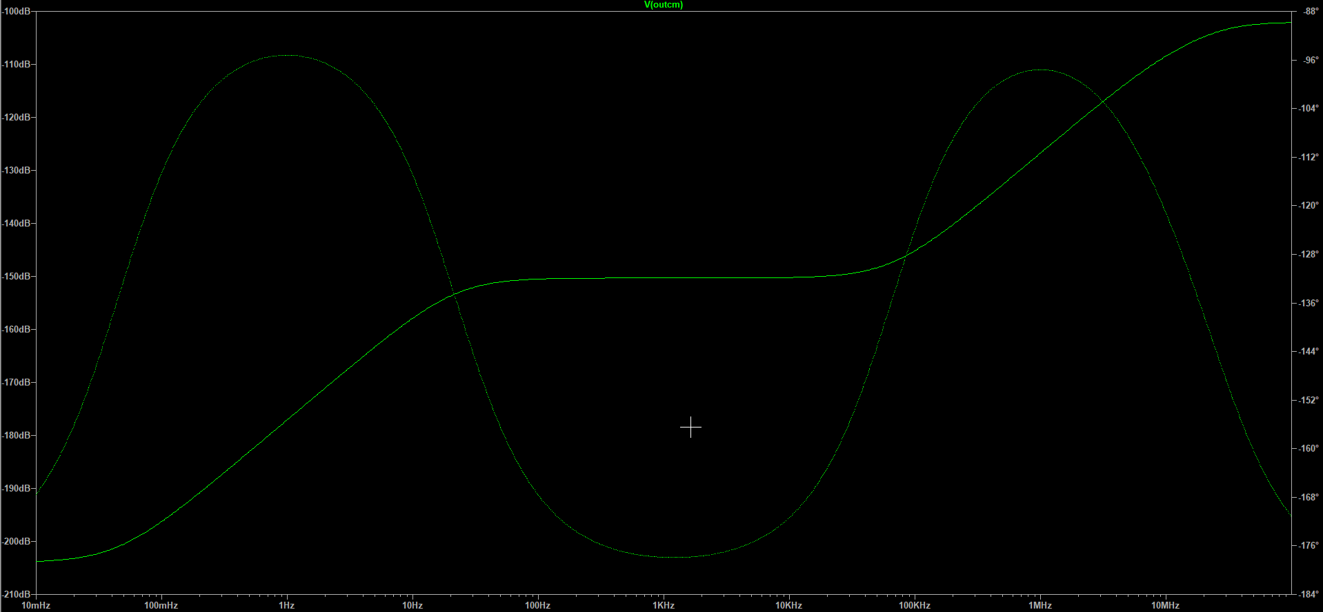

PSRR:

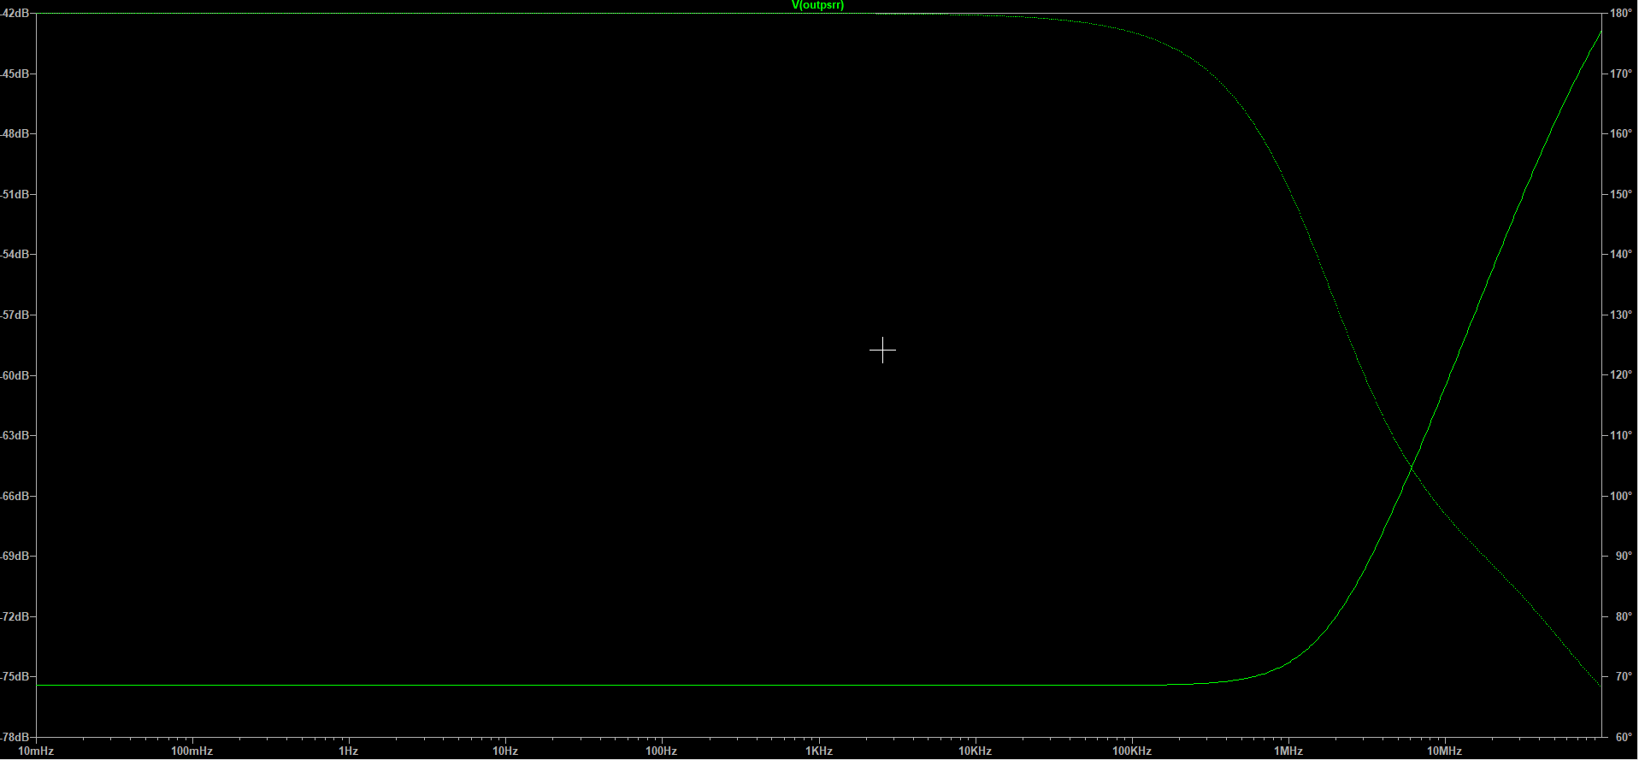

Demonstration of linearity conditions
Simulation used: .tran 0 5m 0

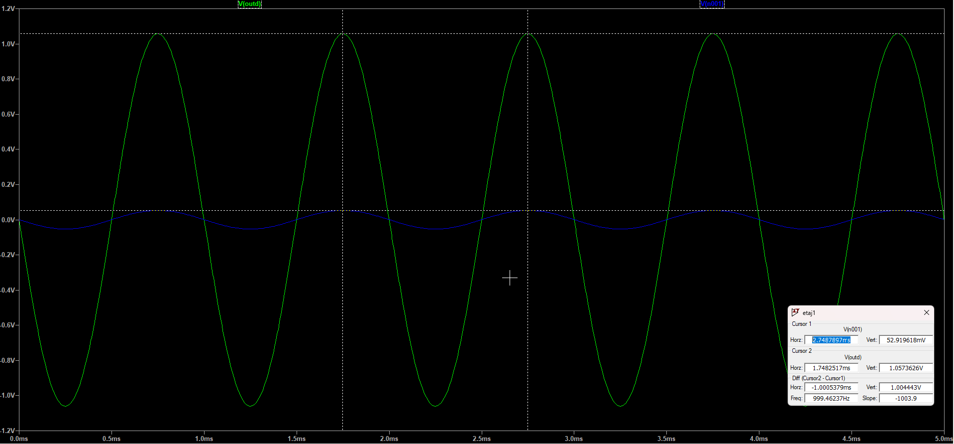

3.2.Characterization of Stage 2

DCOP Parameters:

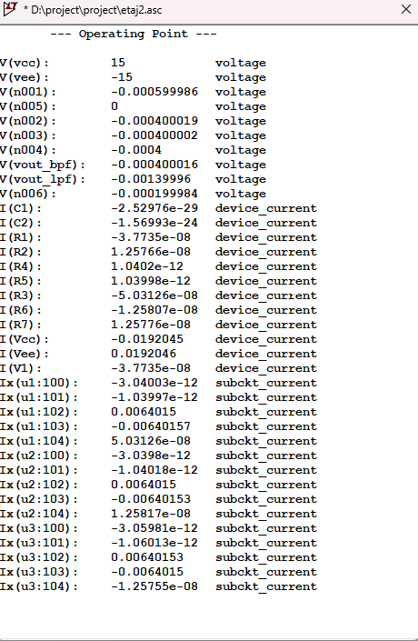

Demonstration of proper band
Simulation used: .ac dec 100 1 10k

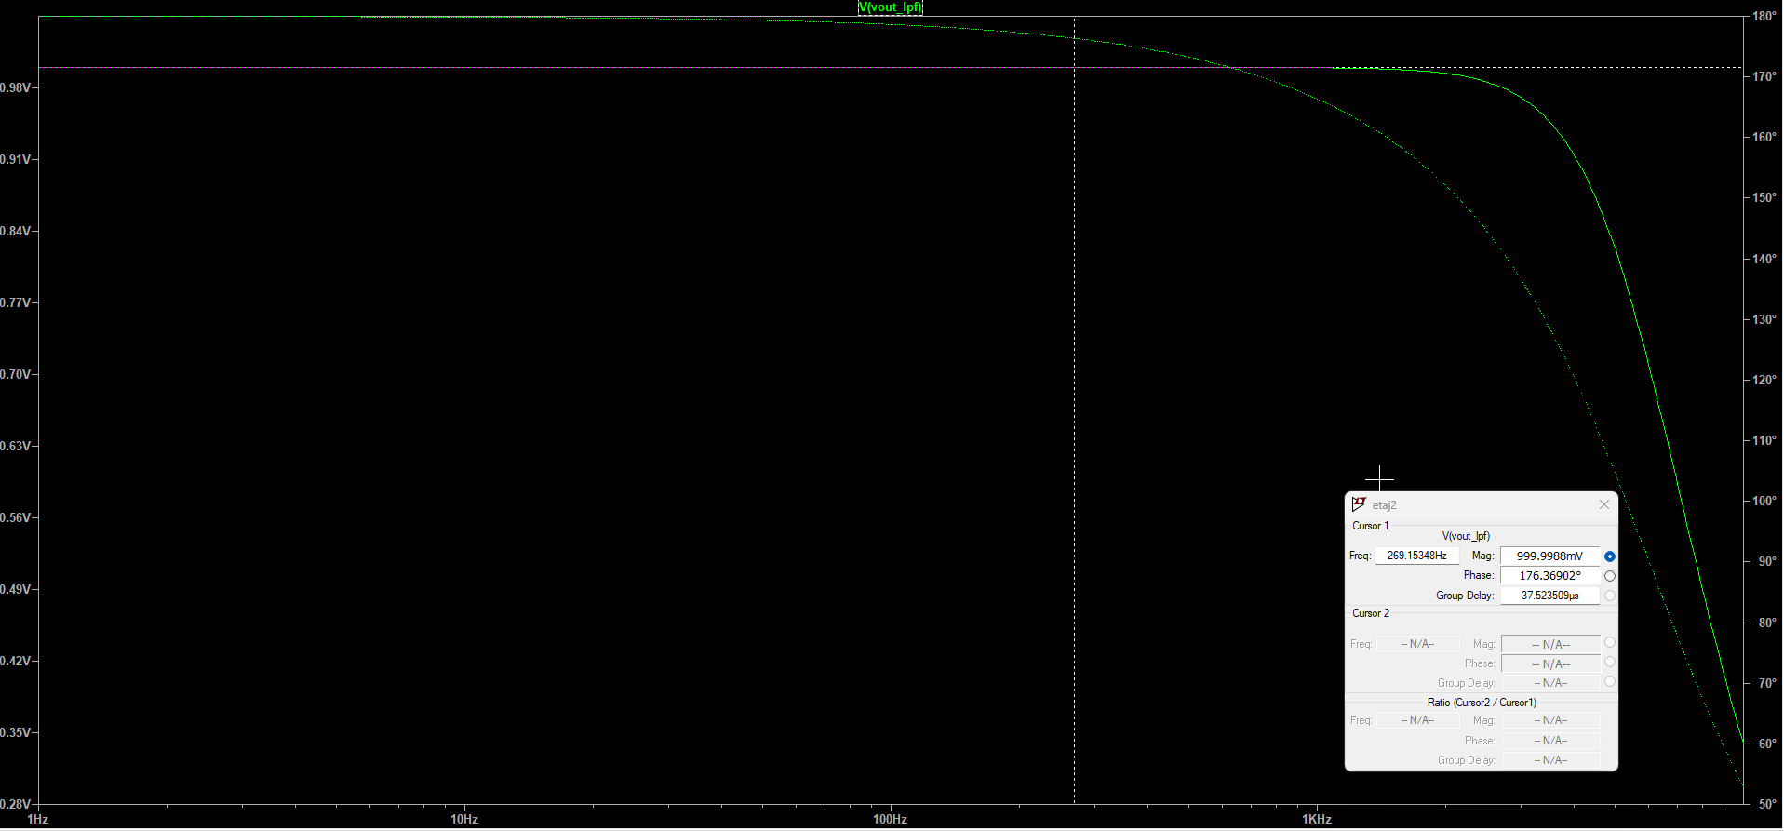

Demonstration of GBW.
Simulation used: .ac dec 100 1 10k

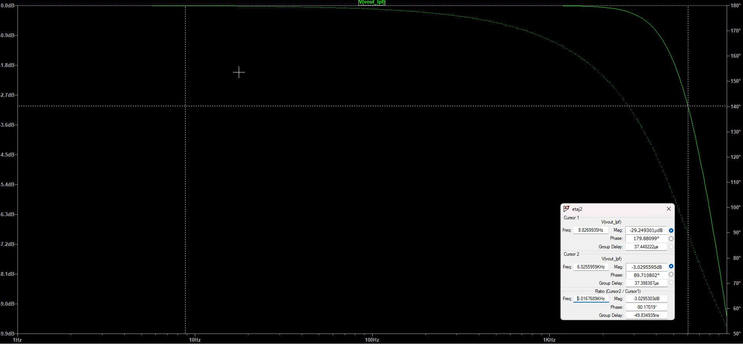

Demonstration of linearity.
Simulation used: .tran 0 5m 0

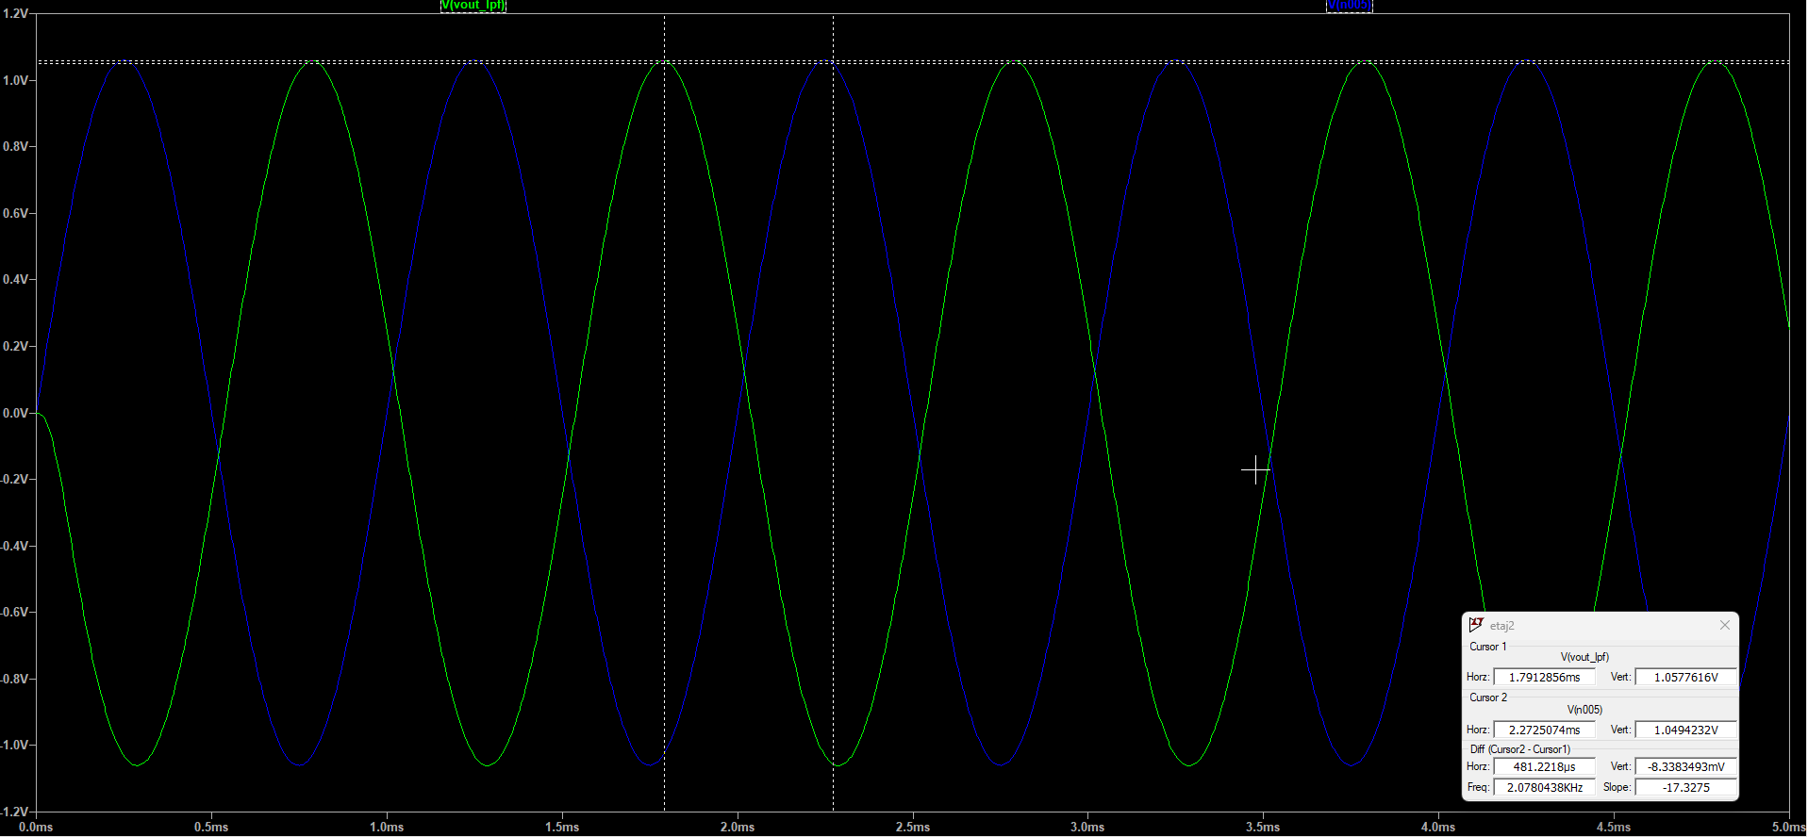

3.3.Characterization of Stage 3

DCOP Parameters:
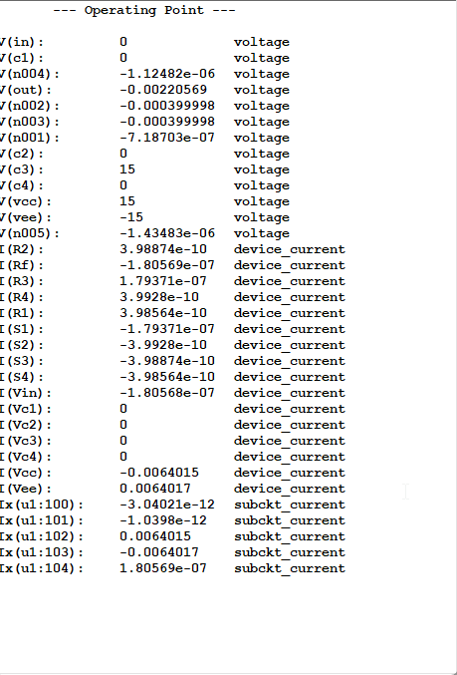
Demonstration of all of the gain steps obtained.
Simulation used: .ac dec 100 .01 100Meg

SW1:
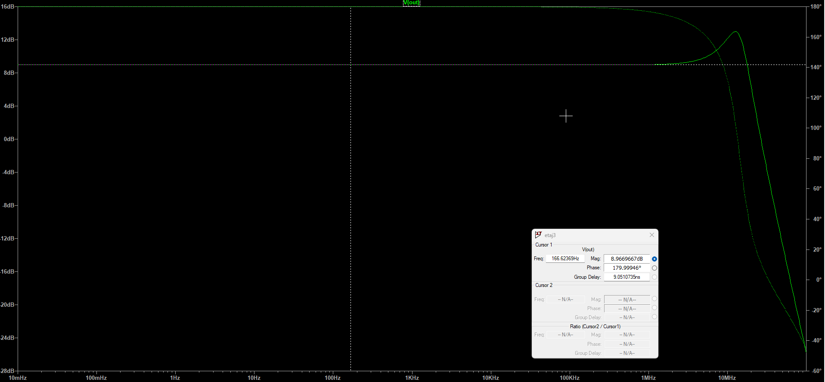

SW2:

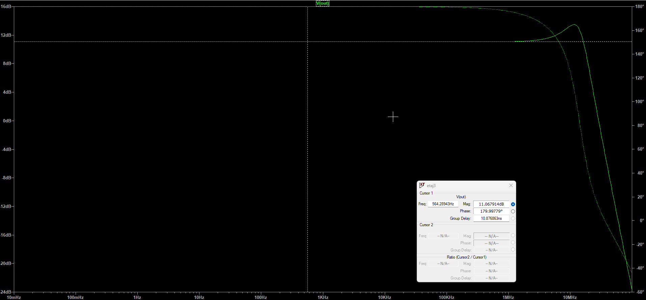

SW3:

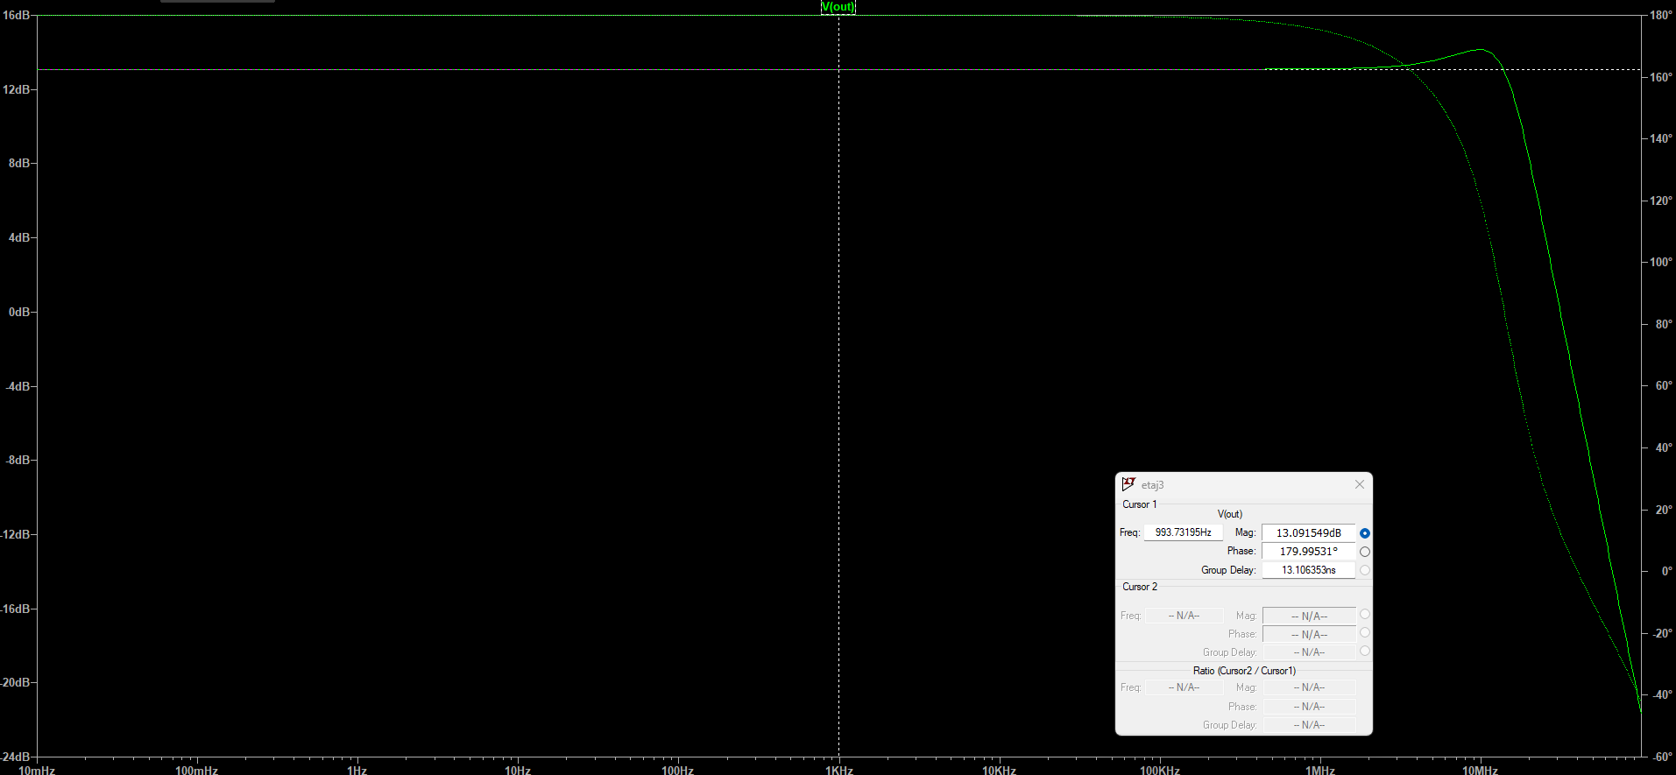

SW4:

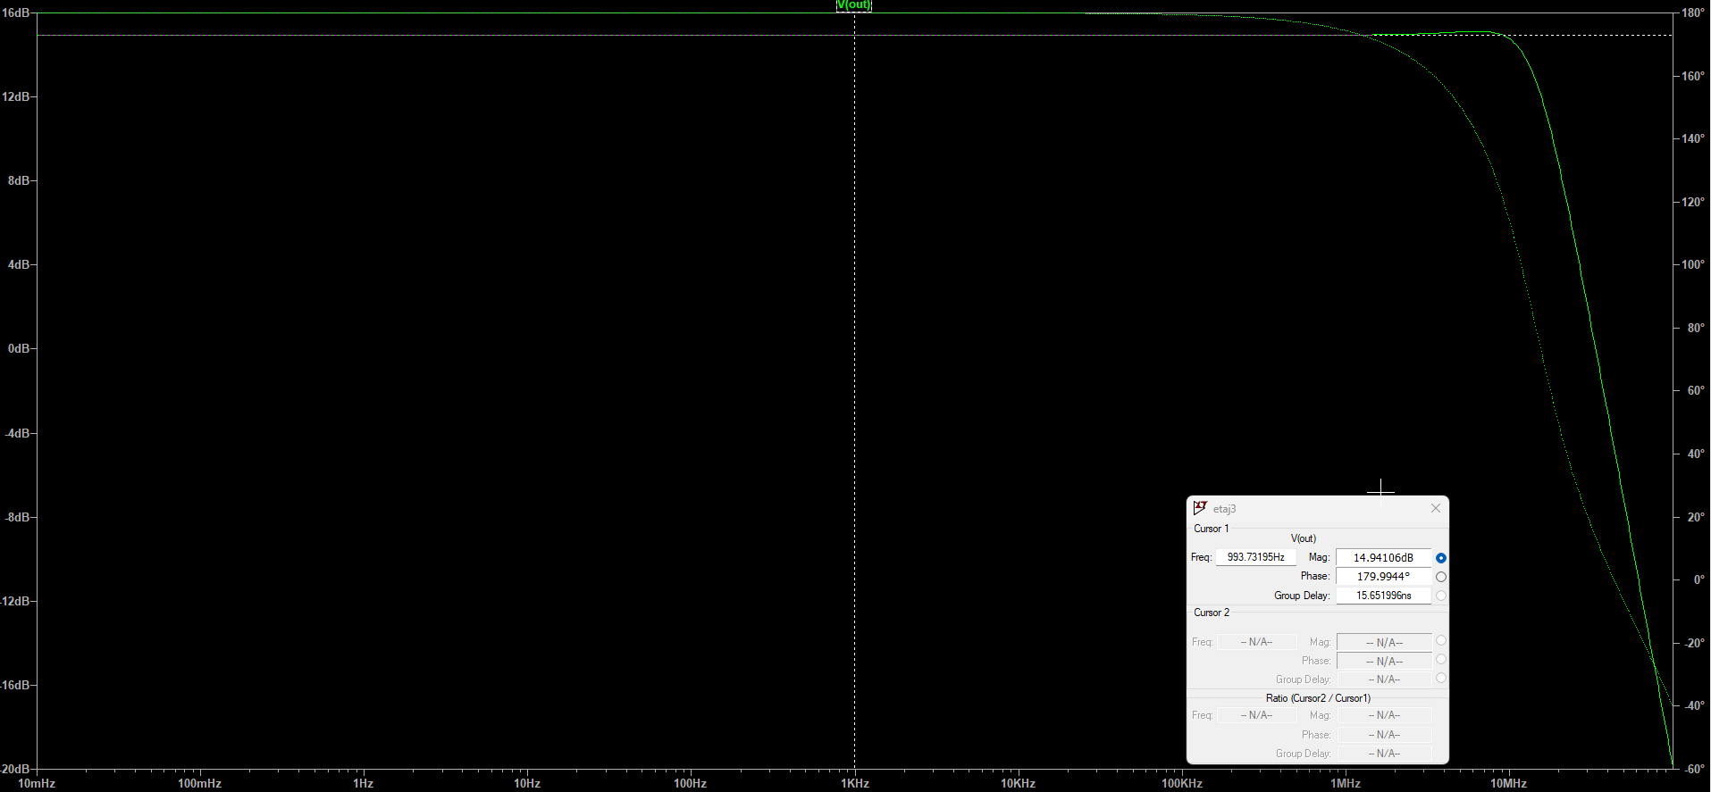

Demonstration off all band values for the gain steps.
Simulation used: .ac dec 100 .01 100Meg

SW1:

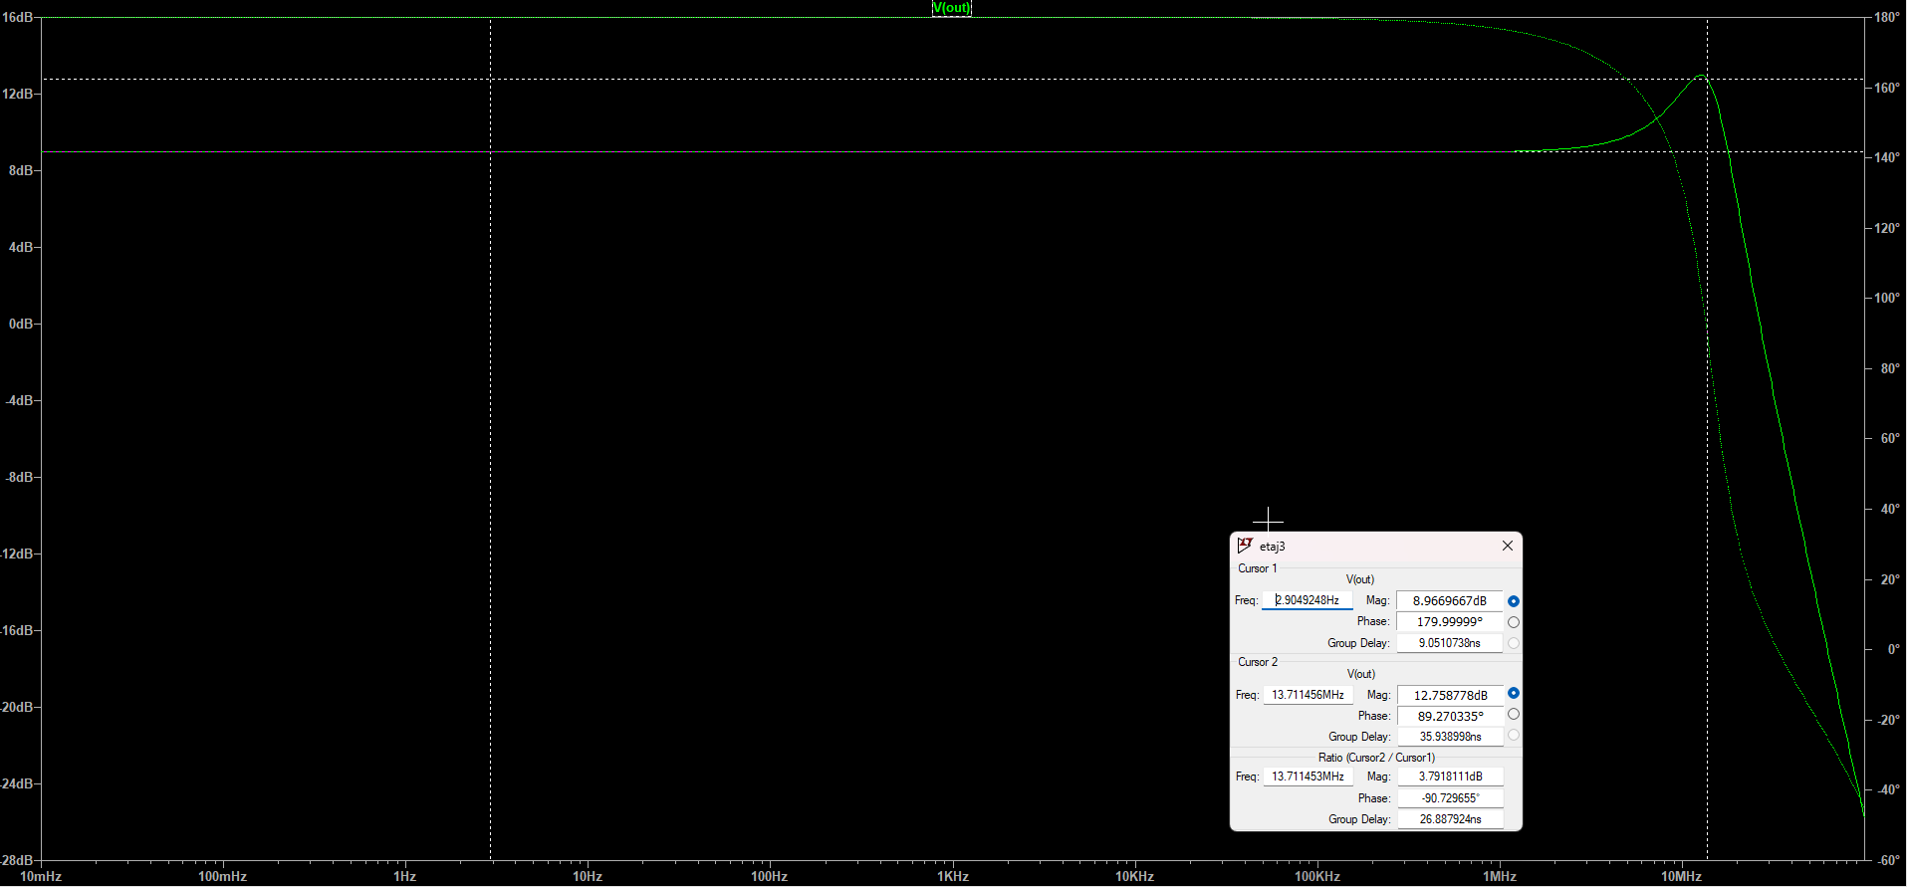

SW2:

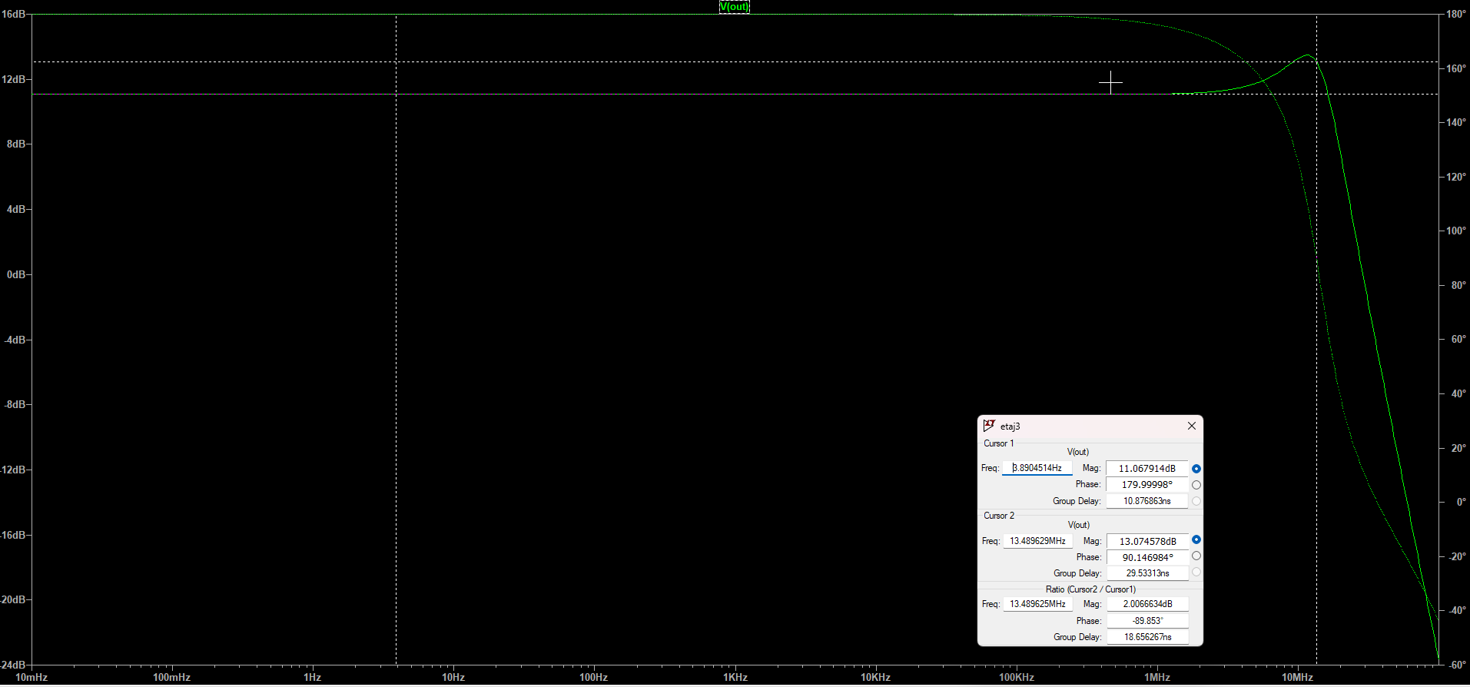

SW3:

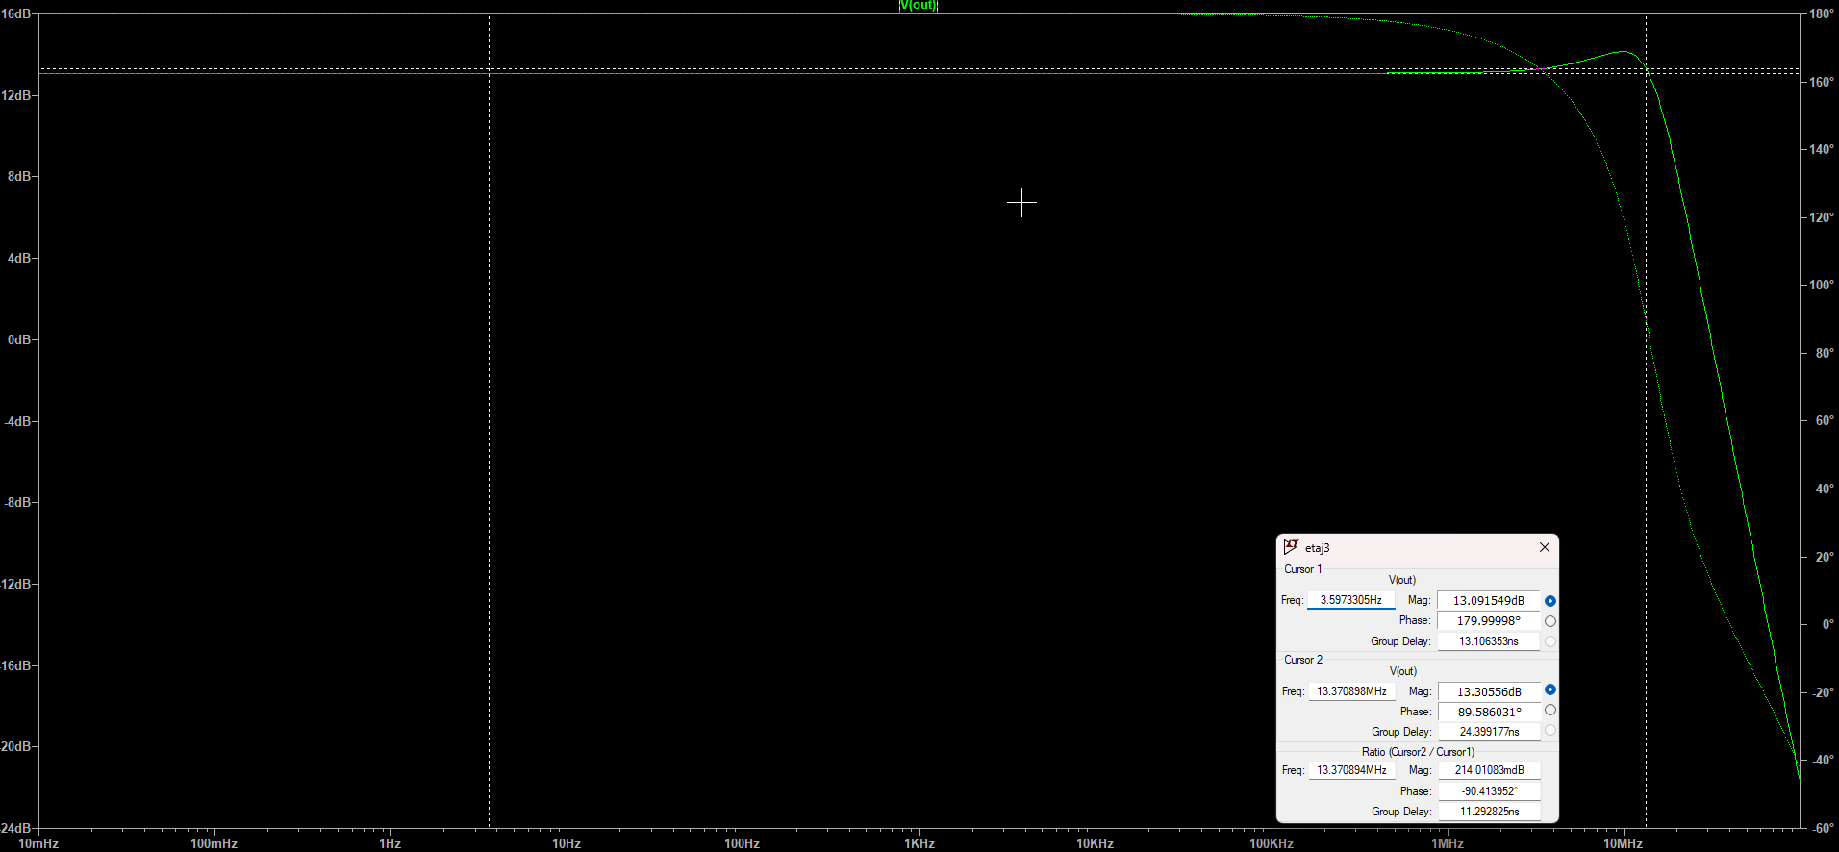

SW4:

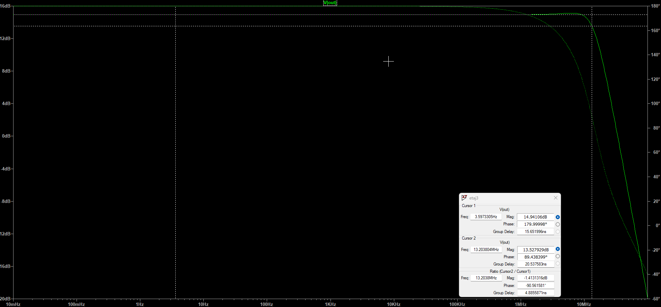

Demonstration of THD and linearity
Simulation used: .tran 0 5m 0 50u

Linearity > specs for minimum gain and maximum input amplitude (for THD < 1%)

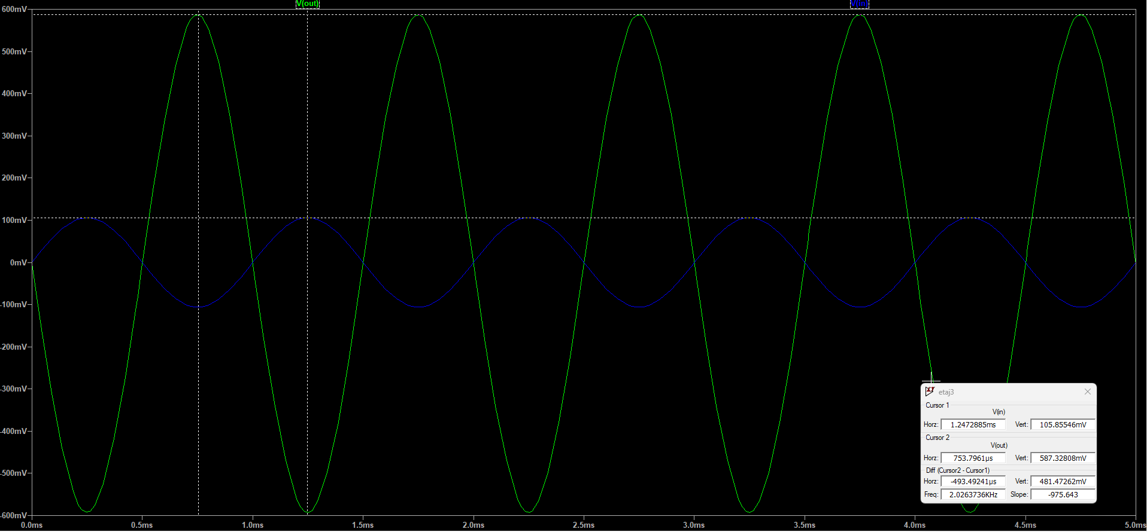

Linearity > specs for maximum gain and minimum input amplitude (for THD < 1%)

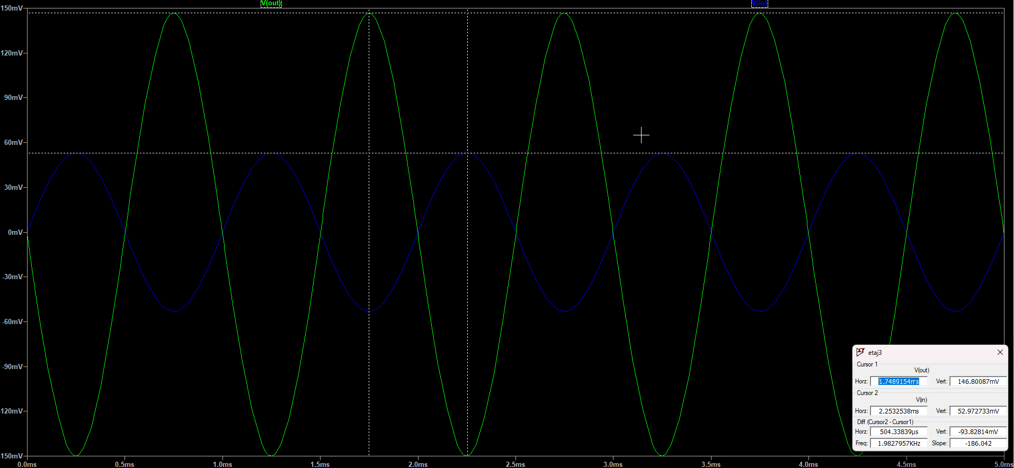

3.4.Characterization of Stage 4

DCOP Parameters:

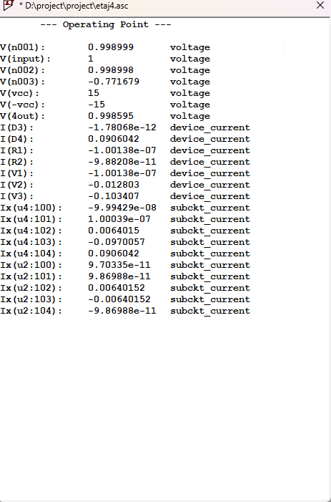

Demonstration of casting in DC sweep
Simulation used: .dc V1 -15 15 0.01
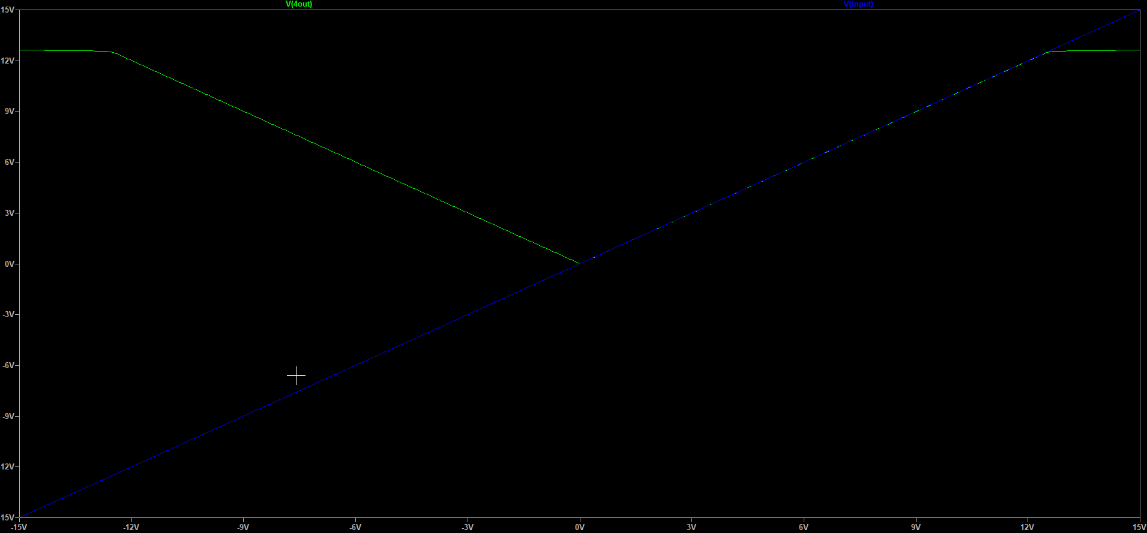
Demonstration of implementing circuit functionality
Simulation used: .tran 0 5m 0 50u

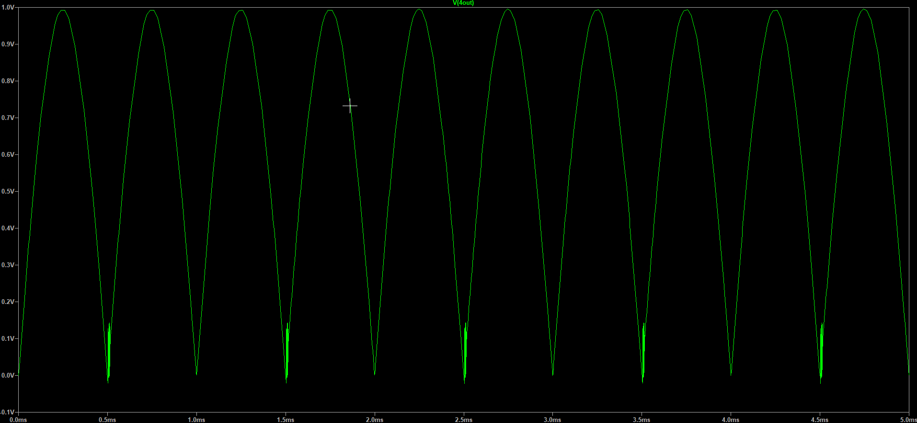

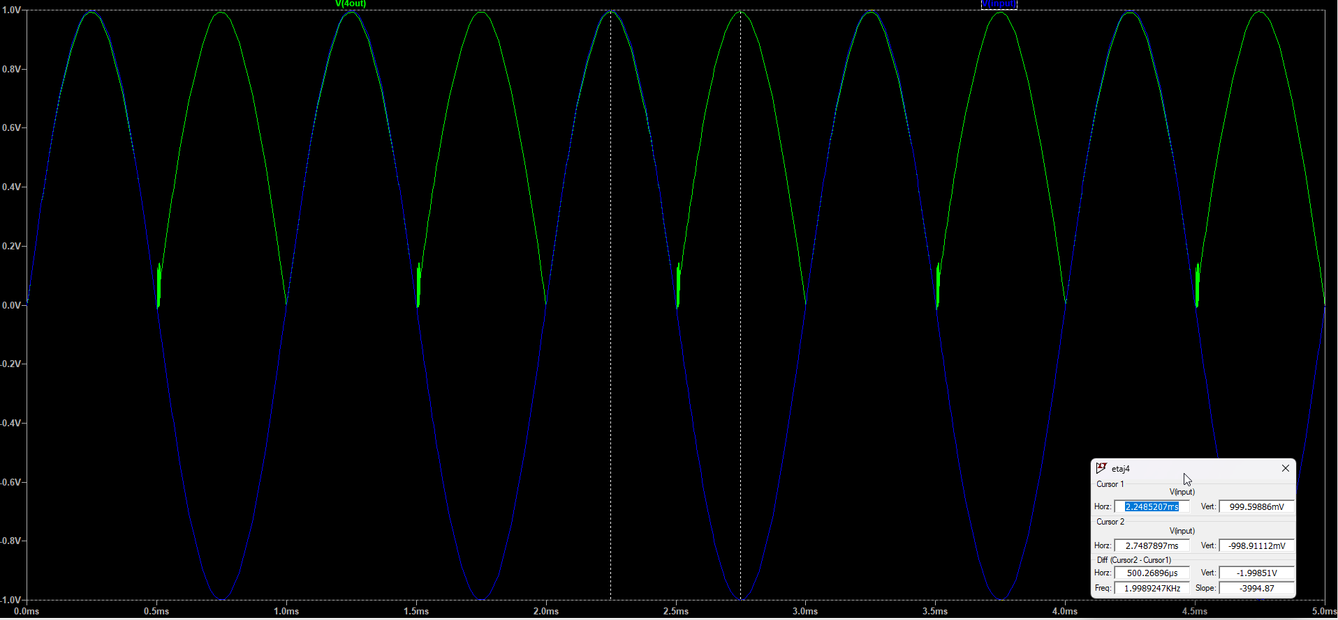

4. Validation and characterisation of the analog interface

The complete analog interface circuit is shown below. It integrates all the designed stages, including all the previously dimensioned components.

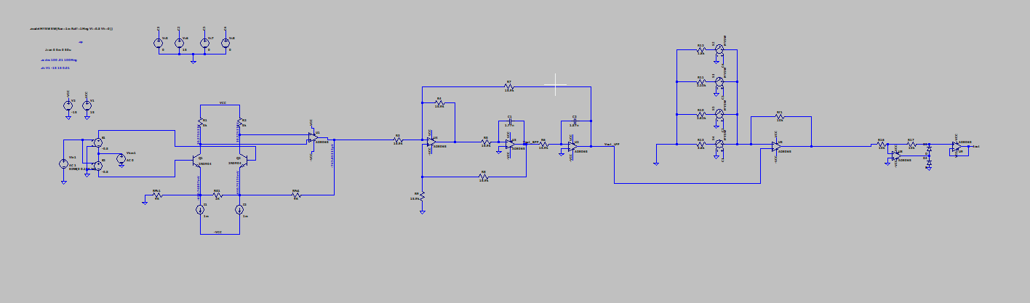

Demonstration of .tran 0 5m 0 50u simulation:

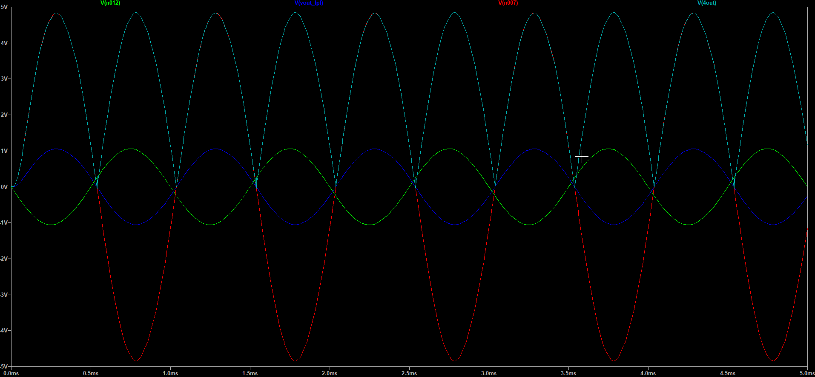

5. Conclusion

 | Specifications | Measurements
|Gain| stage 1 | 10 | 9.997
|H0| stage 2 | 1 | 1
Bandwidth stage 2 | 6000 | 6.016
Gain 1 stage 3 | 9dB | 3.6
Gain 2 stage 3 | 11dB | 2.82
Gain 3 stage 3 | 13dB | 2.23
Gain 4 stage 3 | 15dB | 1.8
|Gain| stage 4 | 1 | 1

Following the measurements of each stage and comparing the results with the required specifications, there are no significant errors or differences, which indicates the correct functionality of the circuit within the required parameters.

The design, dimensioning, and characterization of the proposed analog interface have demonstrated the functionality of the circuit, according to the imposed requirements. The results obtained from the AC and Transient simulations confirm the correct operation of the circuit, validating the design parameters, namely gain, bandwidth, and linear range.

